DVFS ARCHITECTURE

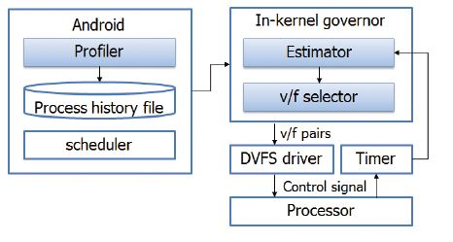

First, a *Profiler* traces a CPU usage of each process and

makes a process history table. Then, *Estimator* brings schedule information from Android scheduler

and estimate which process will be running in next time slice.

Finally, *v/f selector* selects appropriate voltage/frequency set

for next time slice.

To estimate CPU usage of next time slice, the process information is profiled on the fly before v/f

scaling. Android system basically provides the environment

that is capable of extracting the kernel status information and

can be controlled through sysfs (file system) interface. We make

the Process history table (PHT) by saving the MA (moving

average) value of CPU usage of each process of every time

slices. The reason of saving MA is to calculate average CPU

utilization because CPU usage of each processes is varying

with time varies. Profiler saves CPU usage value which is translated when processor runs at maximum

frequency according to following equations.

*CUsaved* = *CUcurrent _ freqmax*

*freqcurrent*

In this equation, *CU* is CPU usage of each process.